Wilson Tennis Shoes
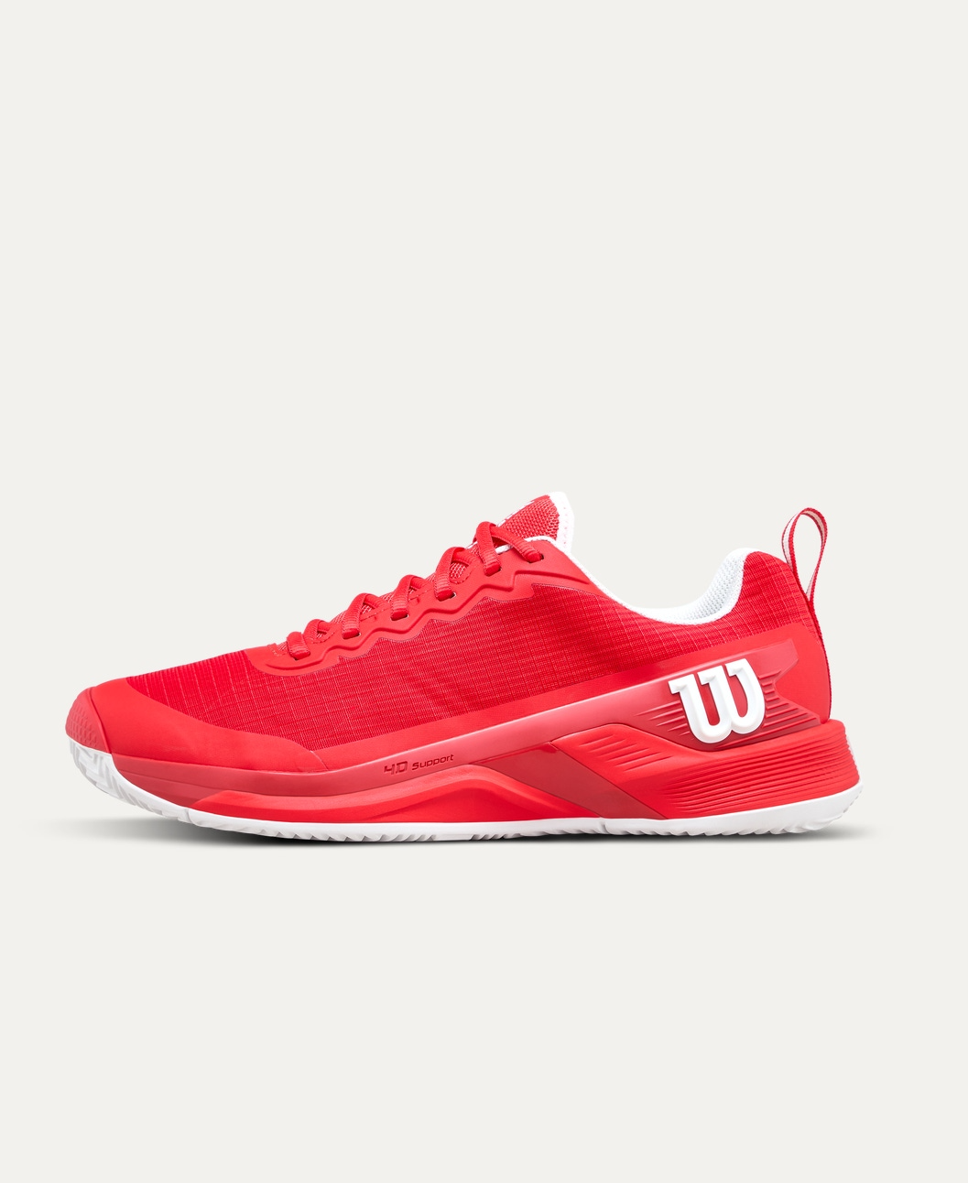
Price: Approximately Rs 35,000
Introduction
Wilson Tennis Shoes are designed to deliver superior comfort, stability, and grip on the court. Built for fast footwork and long matches, these shoes help players move confidently while reducing impact and fatigue.

Product Overview
These Wilson Tennis Shoes combine advanced cushioning with strong lateral support to meet the demands of tennis players. Whether during practice or competitive play, they provide excellent traction and long-lasting comfort.

About the Brand
Wilson is a globally respected sports brand known for producing high-quality tennis equipment. Trusted by professional athletes worldwide, Wilson footwear reflects innovation, durability, and performance-driven design.

Key Features
- Superior court grip for quick movements
- Cushioned midsole for shock absorption
- Strong lateral support for side-to-side motion
- Breathable upper for airflow and comfort
- Durable outsole for long-term use

Design & Build Quality
The shoes feature a sleek, sporty design with reinforced areas for stability. The ergonomic build ensures a snug fit while supporting natural foot movement during intense rallies.

Storage & Capacity
Designed for daily wear and sports use, these shoes fit easily into standard tennis or gym bags without taking extra space.

Material & Durability
Made from high-quality synthetic and mesh materials, Wilson Tennis Shoes offer excellent durability, breathability, and resistance to wear on hard courts.

Ideal For
- Beginner to professional tennis players
- Training sessions and tournaments
- Hard court and multi-court surfaces
- Players seeking comfort and performance

Care Instructions
- Clean with a soft brush or damp cloth
- Air dry after use
- Avoid machine washing
- Store in a cool, dry place

Product Specifications
- Brand: Wilson
- Product Type: Tennis Shoes
- Upper Material: Synthetic & Mesh
- Sole Type: Non-marking rubber outsole
- Closure Type: Lace-up
- Usage: Training & Match Play

Product Summary
Wilson Tennis Shoes offer the perfect balance of comfort, stability, and durability. Designed to support fast movements and long hours on the court, they are an excellent choice for players looking to enhance performance and reduce strain.

Thank you

